
Environmental, Health and Safety Services
Phone 540-231-8751, Fax 540-231-3944
VIRGINIA POLYTECHNIC INSTITUTE
AND STATE UNIVERSITY

Seal Check Procedure for Cartridge Style Respirators
Important Information for Respirator Users:
- You need to conduct a seal check each time you put your respirator on before you enter the respirator use area. The purpose of a seal check is to make sure your respirator (which has been previously fit tested) is properly positioned on your face to prevent leakage during use and to detect functional problems.

- The procedure below has two parts; a positive pressure check and a negative pressure check. You must complete both parts each time. It should only take a few seconds to perform, once you learn it.

- If you cannot pass both parts, your respirator is not functioning properly, see your supervisor for further instruction.

Positive pressure check:

1. Remove exhalation valve cover, if removable.
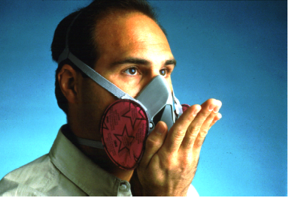
2. Cover the exhalation valve completely with the palm of your hand while exhaling gently to inflate the facepiece slightly.

3. The respirator facepiece should remain inflated (indicating a build-up of positive pressure and no outward leakage).

- If you detect no leakage, replace the exhalation valve cover (if removed), and proceed to conduct the negative pressure check.
- If you detect evidence of leakage, reposition the respirator (after removing and inspecting it), and try the positive pressure check again.

Negative pressure check:

4. Completely cover the inhalation opening(s) on the cartridges or canister with the palm(s) of your hands while inhaling gently to collapse the facepiece slightly.

- If you cannot use the palm(s) of your hands to effectively cover the inhalation openings on cartridges or canisters, you may use:

- Filter seal(s) (if available) OR thin rubber gloves.

5. Once the facepiece is collapsed, hold your breath for 10 seconds while keeping the inhalation openings covered.

6. The facepiece should remain slightly collapsed (indicating negative pressure and no inward leakage).

- If you detect no evidence of leakage, the tightness of the facepiece is considered adequate, the procedure is completed, and you may now use the respirator

- If you detect leakage, reposition the respirator (after removing and inspecting it) and repeat both the positive and negative fit checks.

